WEB1 – assignment 1

Juraj – Hoang Linh

# Web application topic

Sport Shop – website where people can view and buy clothes, shoes, and equipment from famous sport brands, such as: Adidas, Nike, etc.

# Target audience (Individuals)

* Age range: 14 – 40
* The site appeal to both men and women, because they are promising customers in sport field.
* Visitors can be from anywhere, but mostly in Europe (especially Netherlands)
* The average income of visitors can be wide, visitors with high income may have bigger potential.
* Level of education of visitors: can be varied, preferably medium to high.
* Marital/ family status: Any.
* Occupation: Any.
* Visitors who visit the website often will be focused more.
* Device to access the website: phone, tablet, computer, etc.

### Key motivation:

The target audiences are people who interest in sport and people who are aiming to achieve their goals by doing sport. Both personal and professional audience are the target audiences. They see spending time on this activity as essential.

### What information that visitors need

* Online shopping, easy to search, easy to pay and fast deliver.
* Feedback to site’s owner about anything related to the site.
* Is it possible to view the products physically (location of the shop)?
* Discount, on sale products.
* Different kinds of sport.
* In which countries is the site available?
* Social media, Facebook group, etc.
* Viewers’ rates and comments about a product.
* Personal account on the site.

# Site maps

# Wireframe

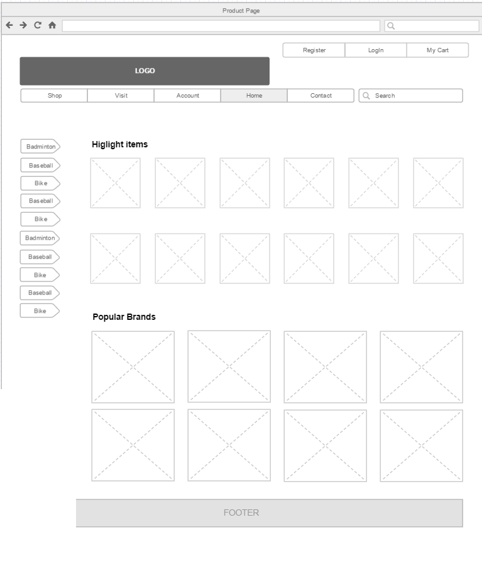

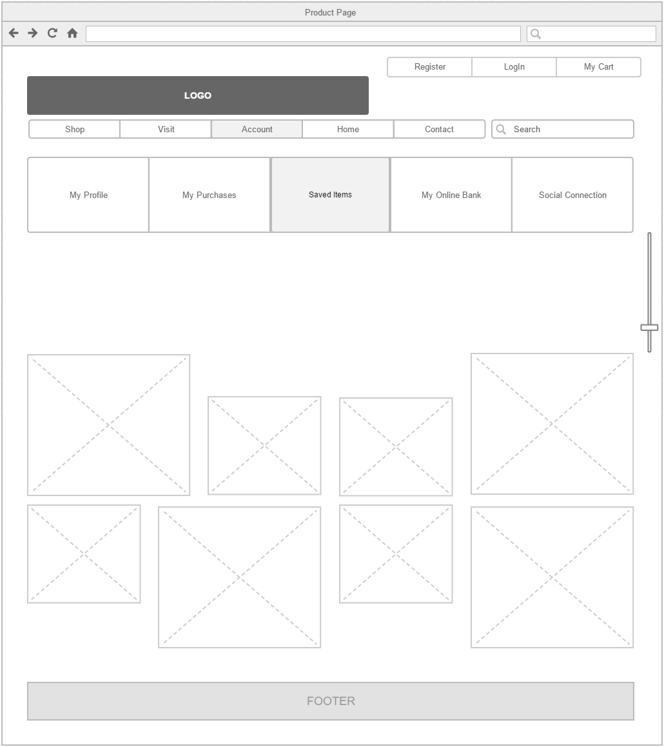

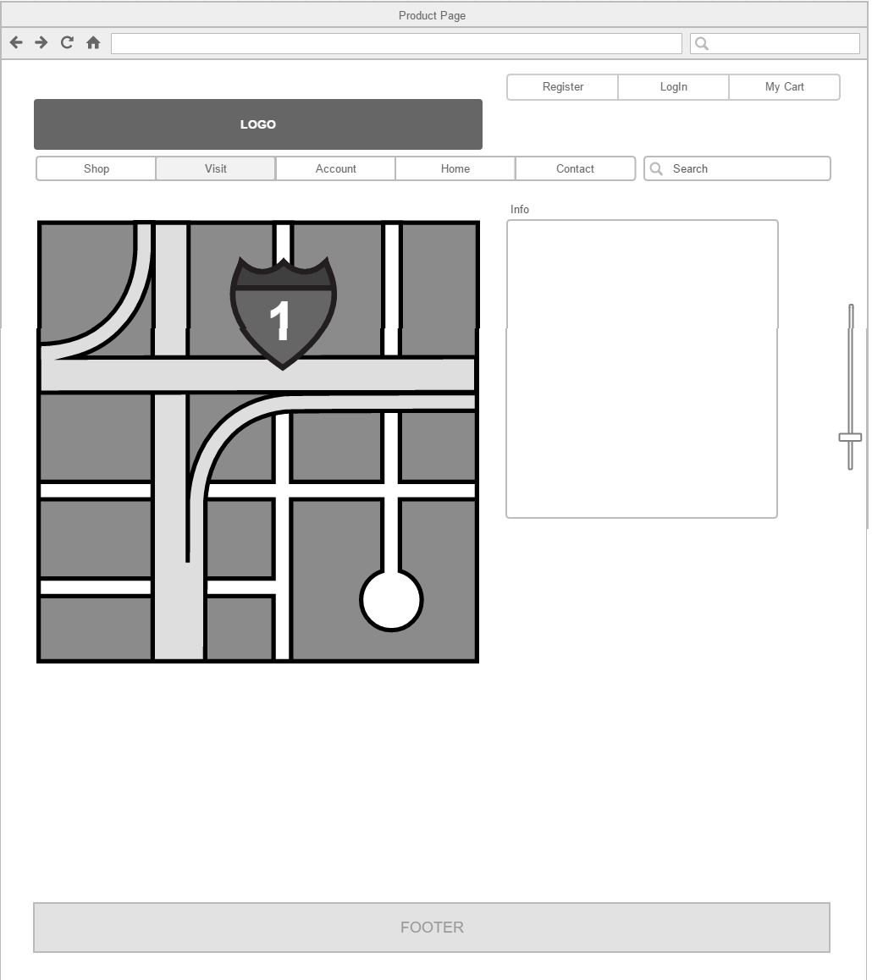

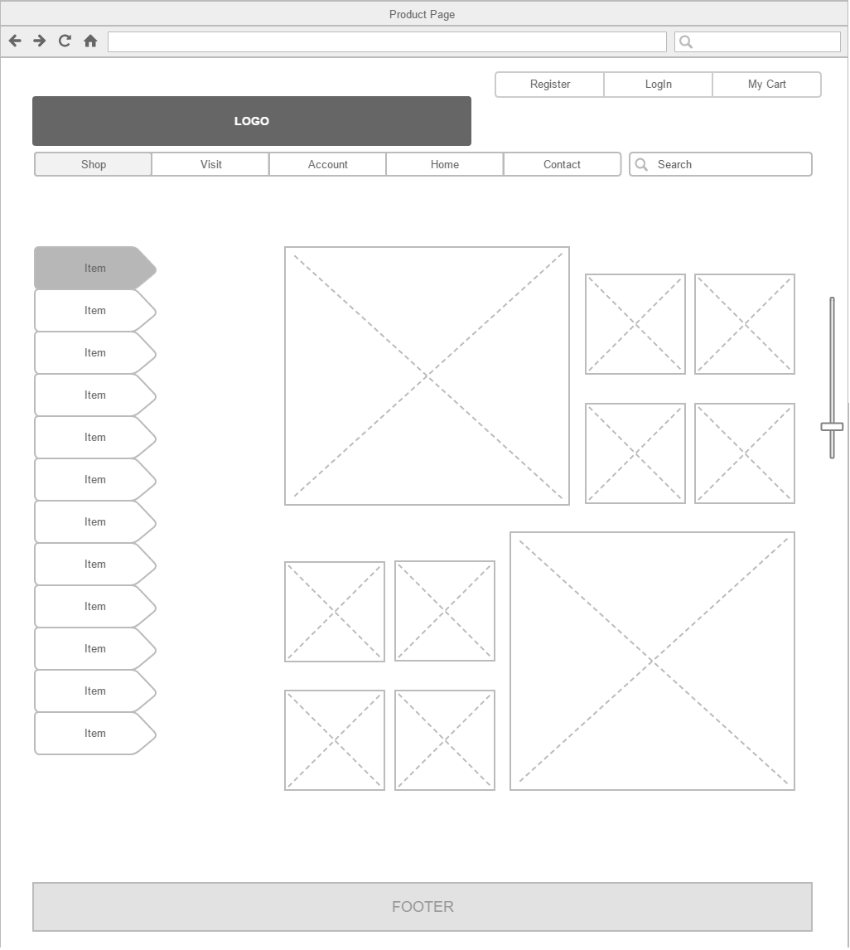

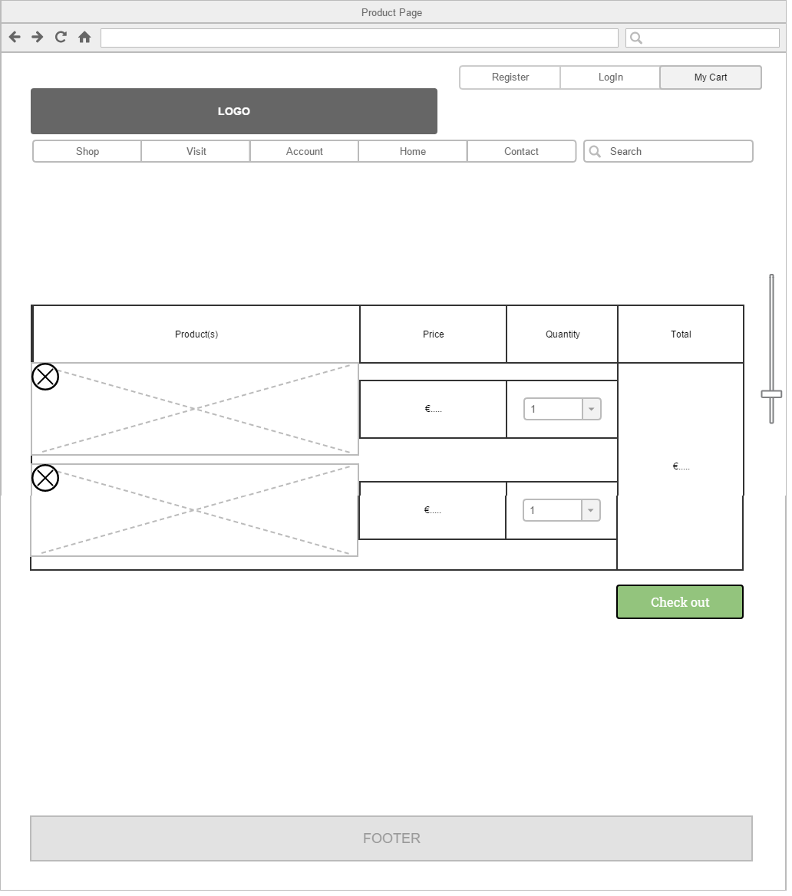

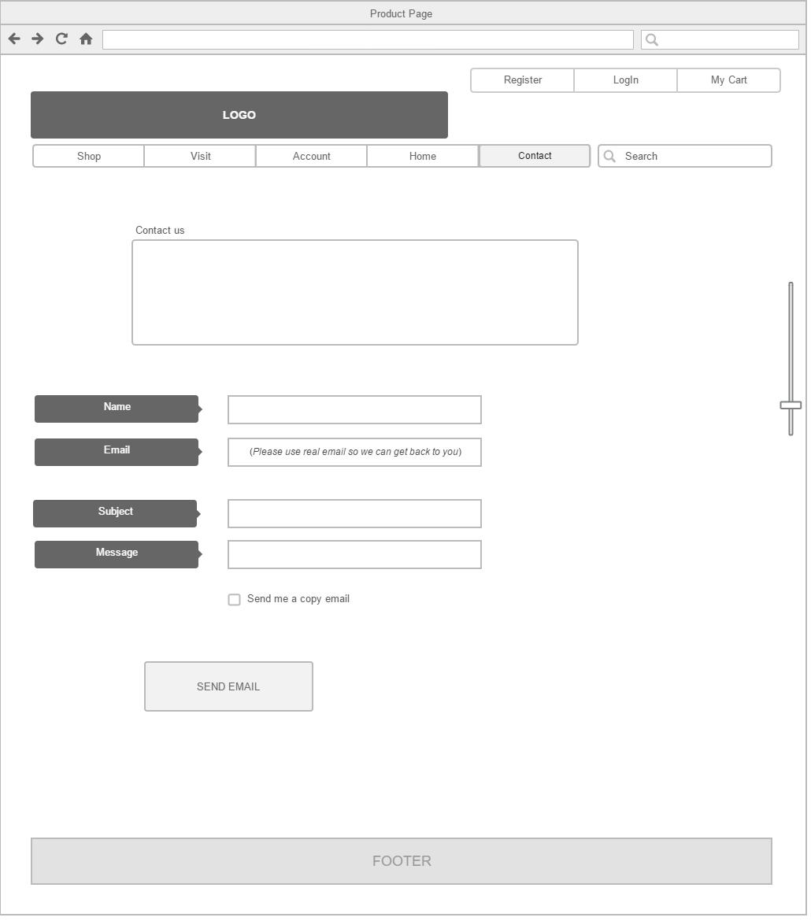

# Visual design

